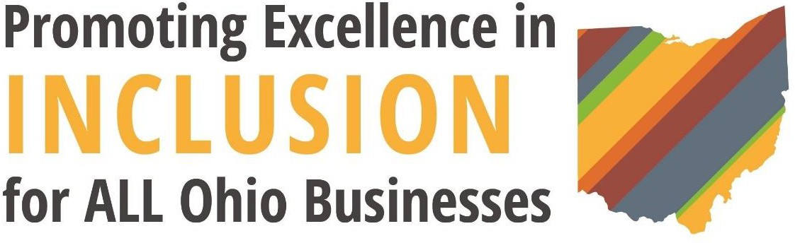

# AGENDA

1:00pm Check-In

# Diversity, Equity, and Inclusion Summit

Wednesday, September 14, 2022 1pm to 7pm

Sheraton Hotel Capitol Square

75 E State Street, Columbus, OH 43215

1:30pm Opening Keynote: The Business Benefits of Creating an Inclusive Business Culture

* Speaker: Stephanie A. Smith, Senior VP, Chief Inclusion and Diversity Officer at Fifth Third Bank

2:00pm Panel Discussion: DEI Best Practices

* Moderator: Patrice Borders, Founder and Principal at Prevention Strategies 3:00pm Break/Transition

3:15pm Breakout Sessions:

1. The Strategic Impact of an Equitable Supply Chain
   * Moderator: Rita McNeil Danish, Diversity, Equity & Inclusion Strategic Business Partner at Taft Law
2. DEI in Today’s Hybrid Workplace.
   * Moderator: Simon Tam (Manager, Strategy and Analytics at Deloitte)
3. DEI and the Aging Workplace Population.
   * Speaker: Kim Shumate (Associate Vice President, Strategic Initiatives, Office of Human Resources at The Ohio State University)

4:15pm Breakout Sessions (same topics as above)

5:00pm Closing Keynote: Leading Fearlessly as a DEI Innovator

* Speaker: Diana Starks, Senior Vice President and Chief Diversity, Equity and Inclusion Officer at Federal Reserve Bank of Cleveland

5:30pm Networking/Happy Hour

# Breakout Session Descriptions:

**The Strategic Impact of an Equitable Supply Chain.**

In this breakout, panelists will discuss the strategic importance of ensuring businesses’ supply chains are equitable. Specifically, the panel will show how underrepresented and minority suppliers can help businesses execute strategies and close gaps in their supply chains. This panel will bring awareness to the strategic advantages that come with having a diverse group of suppliers.

# DEIB in Today’s Hybrid Workplace.

With the growing realities of a hybrid workplace, there are encouraging and disadvantageous DEIB implications. In this point/counter-point discussion, participants will learn the various DEIB impacts of a workplace where some employees come into the office and others engage online. Specifically, the speakers will discuss how hybrid workplaces allow more accessibility for minority employees to work but that there is also an increased risk of proximity bias towards workers that come in person rather than work at home.

# DEIB and the Aging Workplace Population.

In this interactive learning session, attendees will learn the impact of an aging workforce for Ohio businesses. The Ohio Department of Aging estimates that in just 12 years, Ohio will have nine counties where more than one out of every three residents are seniors. This session’s leader will engage participants on what it means to have an aging, multigenerational workforce and its effects on the passing along of institutional knowledge, succession planning, and communication.